Text for social media posts
Recently used NHS Community Mental Health services?
Lookout for the #CommunityMentalHealthSurvey arriving in the post soon. Your valuable feedback will help us improve the quality of our care and people’s experience.
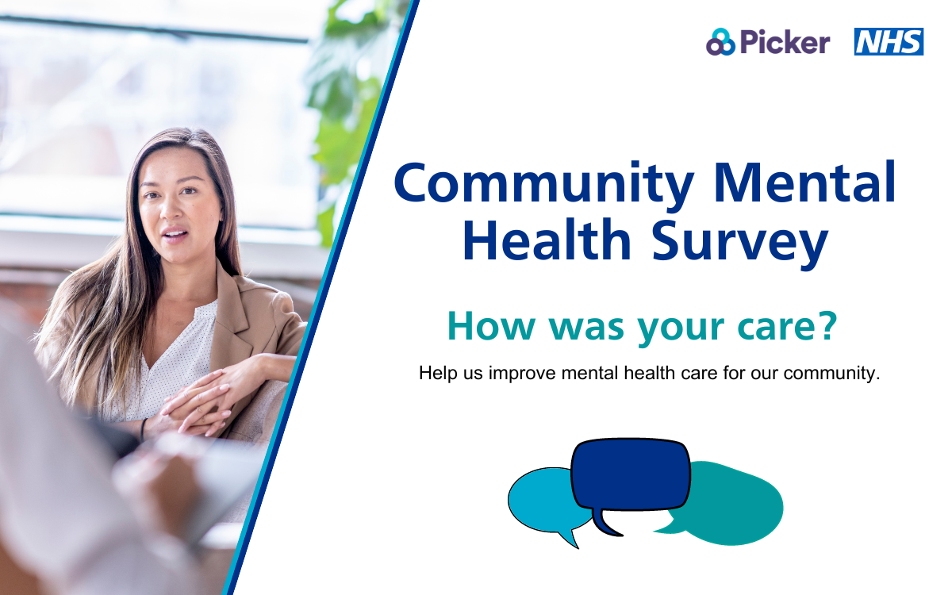
Social media card: Take action

Take the opportunity to make a difference to NHS Community Mental Health care.
We’d love to hear about your experiences. The best way for us to improve your care is by hearing from people who have recently used our services
#CommunityMentalHealthSurvey
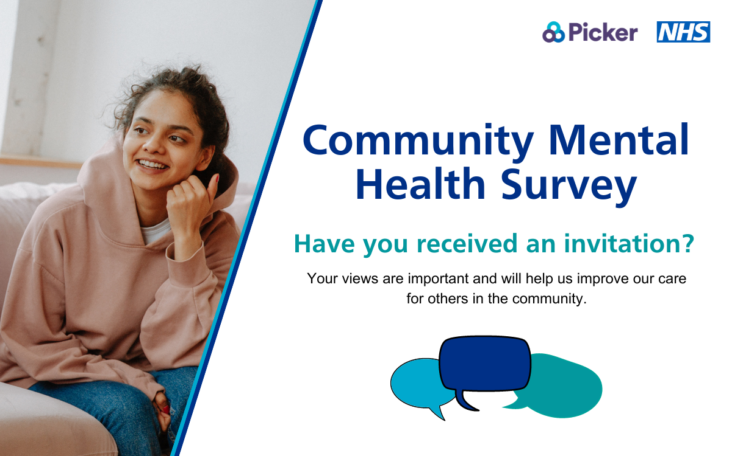
Social media card: Reminder One
Will you take a moment to share your experience mental health care? Lookout for your #CommunityMentalHealthSurvey in the post!
Please take a moment to complete the survey and help us make a positive difference to our care and services.
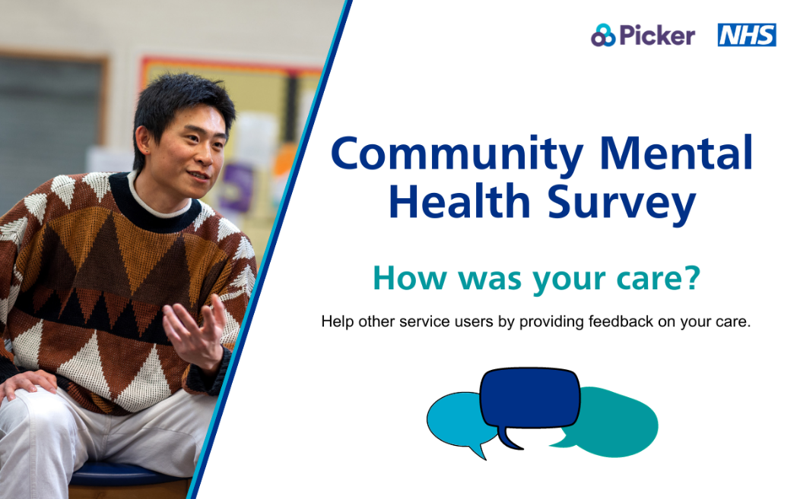
Social media card: Reminder Two

Recently used NHS Community Mental Health services? This is your chance to give feedback on your NHS mental health care.
We are listening closely to what you have to say, your response will help us improve mental health care for you and our community.
#CommunityMentalHealthSurvey
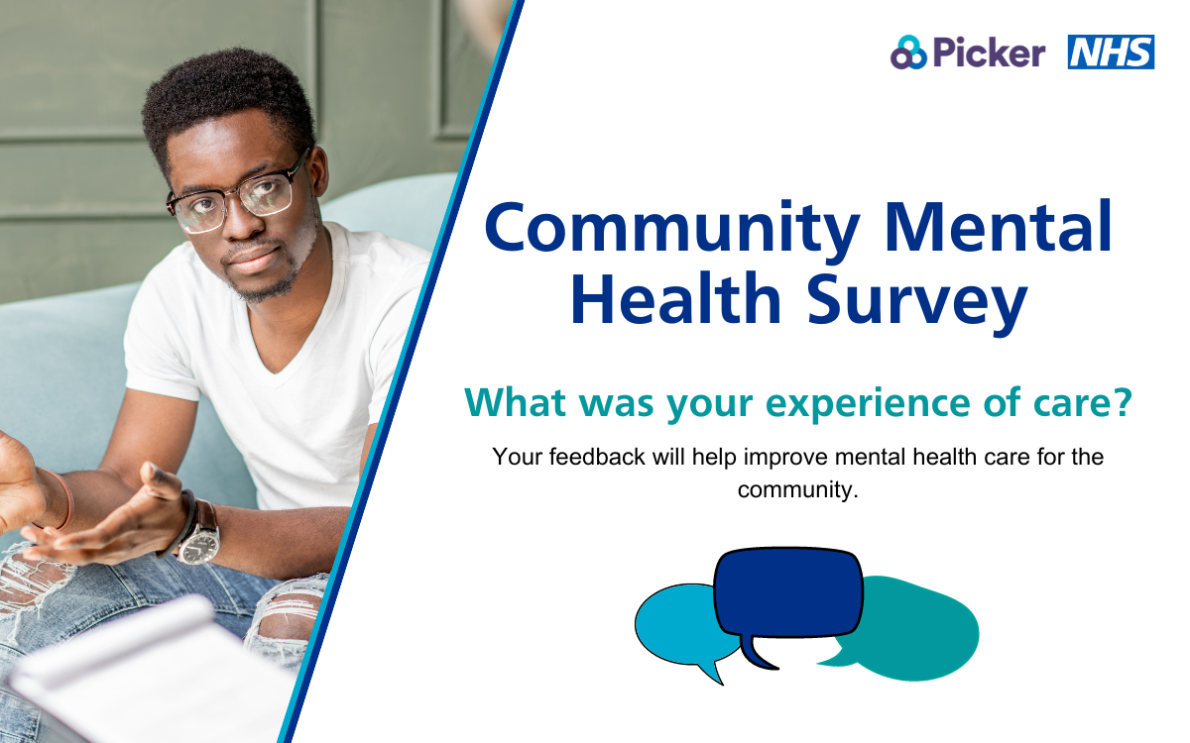
Social media card: Reminder Three

